

**FPT ACADEMY INTERNATIONAL**

**FPT – APTECH COMPUTER EDUCATION**

Beauty Shop

|  |  |  |  |
| --- | --- | --- | --- |
| **Center Name** | | ACE-HCMC-2-FPT  Address: 590 Cach Mang Thang Tam, District 3, Ho Chi Minh City | |
| **Instructor** | | Ms. Dao Ngoc Anh | |
| **Class** | | T1.2103.E1 | |
| **Group** | | 1 | |
| **Group members** | | **Name** | **Student ID** |
| Do Dinh Dai | Student1268268 |
| Le Huu Thang | Student1302889 |
| Nguyen Hoang Minh | Student1287968 |
| **Duration** | **Start date** |  | |
| **End date** |  | |

**This is to certify that**

**Ms./Ms.:**

Do Dinh Dai

Le Huu Thang

Nguyen Hoang Minh

**has successfully designed & developed**

eProject: Beauty shop

**Submitted by:**

**Date of issue:**

**Authorized Signature:**

**TABLE OF CONTENTS**

Contents

ACKNOWLEDGEMENT 4

SYNOPSIS 5

PROBLEM STATEMENT 5

REQUIREMENTS SPECIFICATIONS 6

FUNCTION DIAGRAM OF VISITOR/USERS 8

Description: 8

FUNCTION DIAGRAM OF ADMIN PAGE 9

Description: 9

TASK SHEET REVIEW 1 11

ENTITES AND ENTITY RELATIONSHIP DIAGRAM 12

2. Guest Page: 30

2.Member 35

Entity Relationship Diagram 42

Entity Relationship Diagram (ERD): 42

Table: 43

Table Design: 46

SITEMAP 48

1/GUEST SITE: 48

2/ADMIN SITE: 49

TASK SHEET REVIEW 2 50

USER INTERFACE 51

1. Home page: 51

2. Product page: 52

3. Contact page: 52

4. Product Detail Page: 53

5. Compare Page: 54

6. Login Page: 55

7. Register Page: 56

8. Cart: 56

9. About Us: 57

ADMIN INTERFACE 58

1. Login page: 58

2. View page: 58

3. Create page: 59

4. Update page: 60

TASK SHEET REVIEW 3 62

# 

# 

# ACKNOWLEDGEMENT

It is often said that “Gratitude is the sign of noble souls”. That’s why we devote this chapter to express our deep gratitude towards those who have supported and guided us to accomplish this e-Project successfully.

First and foremost, we strongly appreciate the invaluable assistance that our beloved instructor – Ms. Dao Ngoc Anh, has offered us. Whenever problems come up, she’ll always the one that we can count on for solutions. Anytime when our team chose a wrong way, Ms. Anh gave us a pep talk to keep us back on the track. Therefore, once again, we truly value your dedication and guidance, Ms. Dao Ngoc Anh.

Next, it would have been impossible to carry out and complete this project without the collaboration among our team members. Although we have gone through many obstacles during the project implementation, eventually we gained what we aimed at by our hard work, our strong commitment and of course.

Finally, thanks to this e-Project assignment, we had a golden opportunity to apply what we have learnt into reality and gain hands-on experience which is essential for our future career.

# SYNOPSIS

Nowadays, online shopping is an important and potential market. After gathering enough information about the products and prices, online customers can decide to buy it or not without coming to the store.

Due to this reason, many people have taken advantages of the Internet to promote their brands and attract more customers via their websites. This method can help increase their revenue significantly.

To help our customers to buy items without going to our stores, we have decided to build a website for our customer’s convenience. Now, customers can view all of our products and order online from their home.

Besides that, this website can help us to manage, edit, and post product’s information more easily. We can also deliver our vital information about new products and promotions to our customers through the website.

# PROBLEM STATEMENT

After understanding our requirements from Simplon, our group has discussed about what should to be done to fulfil their requirements properly. We came to conclusion that in order to achieve the best result, we should deal with following queries:

**For the visitor’s website:**

* A home page will show the popular products, sliders introduce new items or new promotions.
* A menu which will include all the functions implemented in the website.
* A product page will allow customer to check the product’s detail and order online.
* A register page for customer to create a new account.
* A login page for customer to access their account to choose items and checkout finally with the entire shopping cart.

**For the admin’s page:**

* A login page will grant access Simplon’s admin.
* A view page for Simplon’s admin can check, or edit data of our products, and other accounts.
* A create new account page allows admin to create new account with specific functions.

# 

# REQUIREMENTS SPECIFICATIONS

1. **Client: SIMPLON’s Beauty care Information** website
2. **Business/Project Objective:**

Provide a website to displays the programs and services about shop such as : “Products”, “About us”, “Contact us”, “Feedback”,...

Enable customer to see what event that they would like. Easier in interactive with us.

1. **Input to the system:**

**For admin’s page:**

* Information of products to create, update, or delete data of products.
* Basic information of account (username, password, role) to create new admin account.

For visitor’s page:

* Information of customer’s order (quantity, product, price…).
* Basic information of account (username, password, email, phone) to create new user account.

1. **Output of the system:**

**For admin’s page:**

* Display information of customers and customer’s orders.
* Display functions for manipulating database provided by the system (add, edit, delete, etc.)
* Display a list of existing admin accounts (manager, seller).

**For visitor’s page:**

* Display list of products, and promotions.
* Display user information.
* Display form for customer’s feedback.
* Display customer’s orders.

**Hardware/ Software Requirements**

**Hardware Requirement:**

* Processor 2 GHz or faster
* Display of 1366x768 resolution or better
* 4 GB RAM or better.

**Sofware Requirement:**

* Windows 7 or higher
* PHP 7.0 or above - My SQL.
* Google Chrome/Mozilla Firefox browsers
* Laravel 8+.
* Sublime text or Visual Studio Code.

**Sever-side Software Requirements:**

* XAMPP Server

# FUNCTION DIAGRAM OF VISITOR/USERS

Header

Home

Product

About Us

Contact

Login/Register

Shopping Cart

Feedback

Product Detail

### 

### 

## Description:

* **Home:** show list of new products, promotions, and best-seller products.
* **Product**: show many products and attribute.
* **About Us**: introduce about our store.
* **Contact Us**: show our shop’s information (phone, email, address).
* **Feedback**: allow customer to send their feedback to us.
* **Login/Register**: allow customers to login into their account or creating new account.
* **Shopping Cart**: show list of customer’s orders.

# FUNCTION DIAGRAM OF ADMIN PAGE

Create, edit, view, delete

Login

Check Login

Yes

No

## Description:

**Log in**: grant access to admin from Simplon if they provide correct their username, password and account type.

**For the admin, they can:**

1. Manage Manager Accounts: view, add, edit, delete admin accounts
2. View, add, edit, delete product, price, discount ...
3. Manage Customer Accounts: view information, check orders.

**For the manager, they can:**

1. Manage Seller: view, add, edit, delete admin accounts
2. Manage Customer Accounts: view information, check orders.

# TASK SHEET REVIEW 1

|  |  |  |  |  |
| --- | --- | --- | --- | --- |
| **No.** | **Description** | **Begin Date** | **Team Mate Name** | **Notes** |
| 1 | Acknowledgement | 07/12/2021 | Do Dinh Dai  All Team |  |
| 2 | Problem Statement | Do Dinh Dai |  |
| 3 | Requirement Specification of Website. | Nguyen Hoang Minh |  |
| 4 | Function Diagram of Visitor | Le Huu Thang |  |
| 5 | Function Diagram of Administrator | Le Huu Thang |  |
| 6 | Task Sheet | Le Huu Thang |  |

|  |  |
| --- | --- |
| **Date:** | |
| Signature of Instructor:  **MRS.DAO NGOC ANH** | Signature of Team Leader:  **MR.LE HUU THANG** |

# ENTITES AND ENTITY RELATIONSHIP DIAGRAM

**I/ Use Case and Sequence Diagram:**

1/ Admin page:

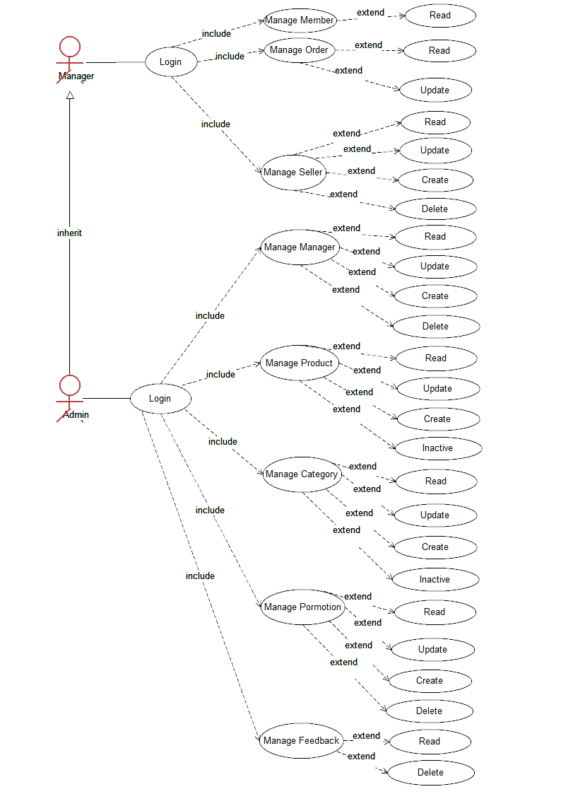

**a) MANAGER:**

1/ Manage member – read:

|  |  |  |
| --- | --- | --- |
| **Use Case Name** | Manage member - read | |
| **Actors** | Manager - Admin | |
| **Description** | Admin wants to view member information | |
| **Requirements** | Login as Admin (Manager - Admin) | |
|  | **Actor Actions** | **System Responses** |
| **Basic Flow** | Click on view member navigator | Display all member’s information table |

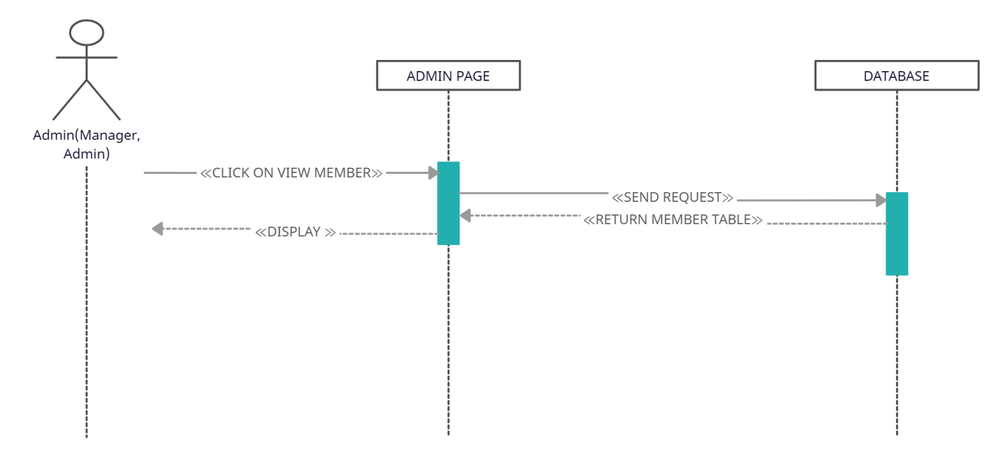

2/ Manage order – read:

|  |  |  |
| --- | --- | --- |
| **Use Case Name** | Manage order - read | |
| **Actors** | Manager - Admin | |
| **Description** | Admin wants to view order information | |
| **Requirements** | Login as Admin (Manager - Admin) | |
|  | **Actor Actions** | **System Responses** |
| **Basic Flow** | Click on view order navigator | Display all order’s information table |

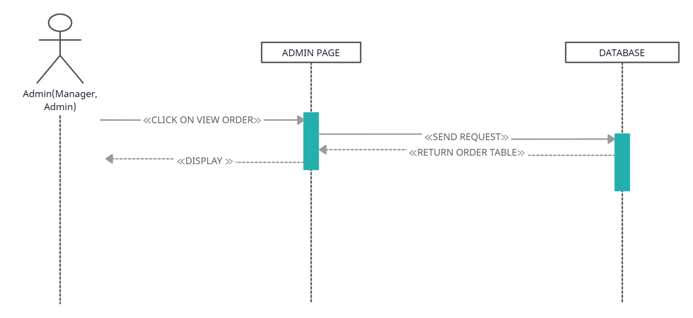

3/ Manager order – update:

|  |  |  |
| --- | --- | --- |
| **Use Case Name** | Manage order - update | |
| **Actors** | Manager - Admin | |
| **Description** | Admin wants to update order status | |
| **Requirements** | Login as Admin (Manager - Admin) | |
|  | **Actor Actions** | **System Responses** |
| **Basic Flow** | Select value in dropdown list: Process Status. Then clicks on Update button | - Display possible values base on the dropdown list: “Hold” and “Completed”  - Update new status for order in database  - Display order’s status on Admin page. |

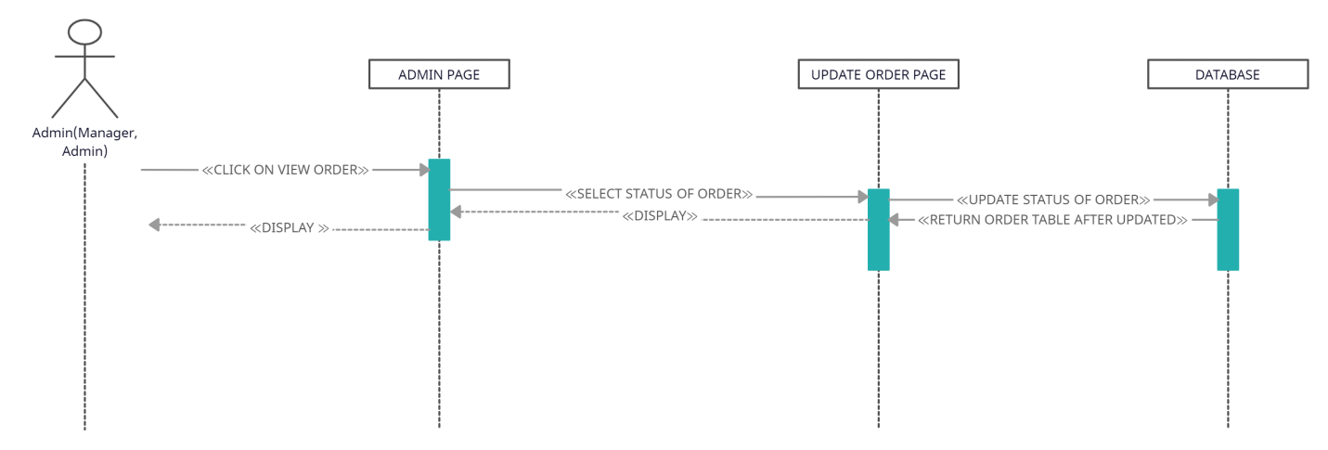

4/ Manage Seller – read:

|  |  |  |
| --- | --- | --- |
| **Use Case Name** | Manage Seller - read | |
| **Actors** | Manager | |
| **Description** | Manager wants to view seller information | |
| **Requirements** | Login as Manager | |
|  | **Actor Actions** | **System Responses** |
| **Basic Flow** | Click on view seller navigator | Display seller’s information table |

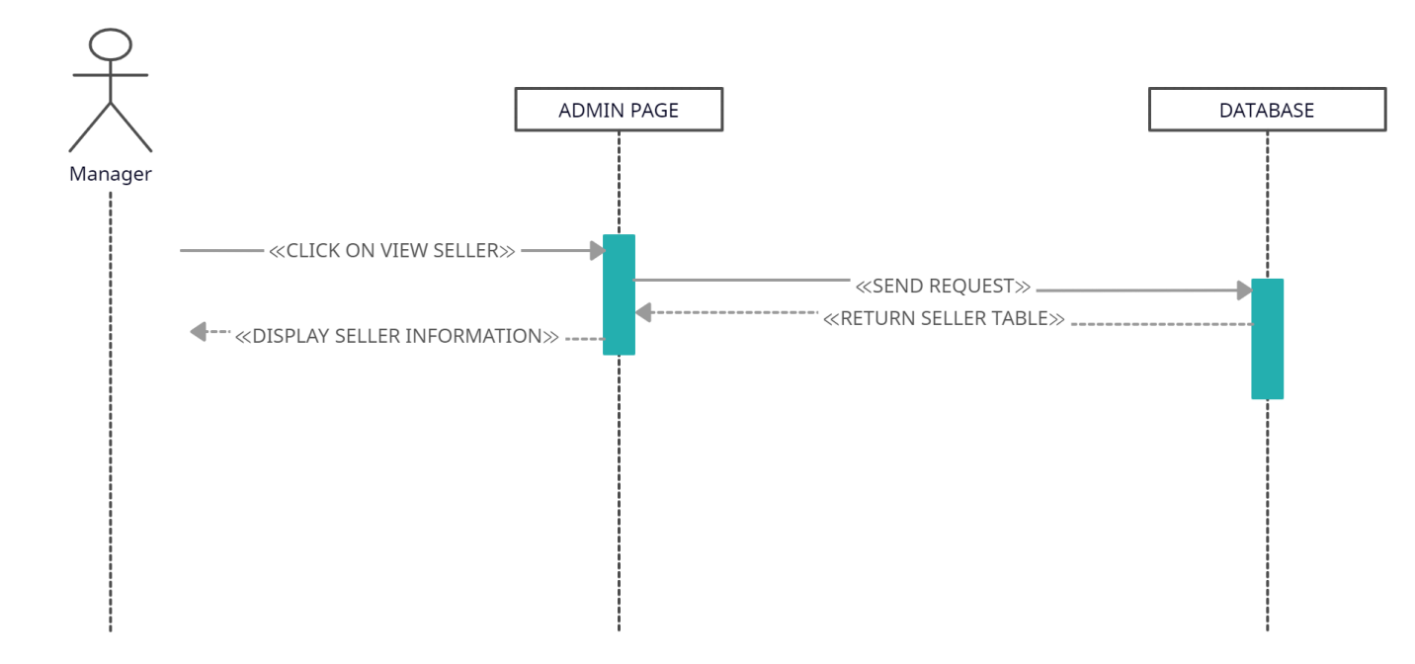

5/ Manage Seller – update:

|  |  |  |
| --- | --- | --- |
| **Use Case Name** | Manage Seller - update | |
| **Actors** | Manager | |
| **Description** | Manager wants to update seller’s information | |
| **Requirements** | Login as Manager | |
|  | **Actor Actions** | **System Responses** |
| **Basic Flow** | - Edit seller’s information that they want to adjust.  - Click update button. | - Update new information for seller in database.  - Display new seller’s information on Admin page. |

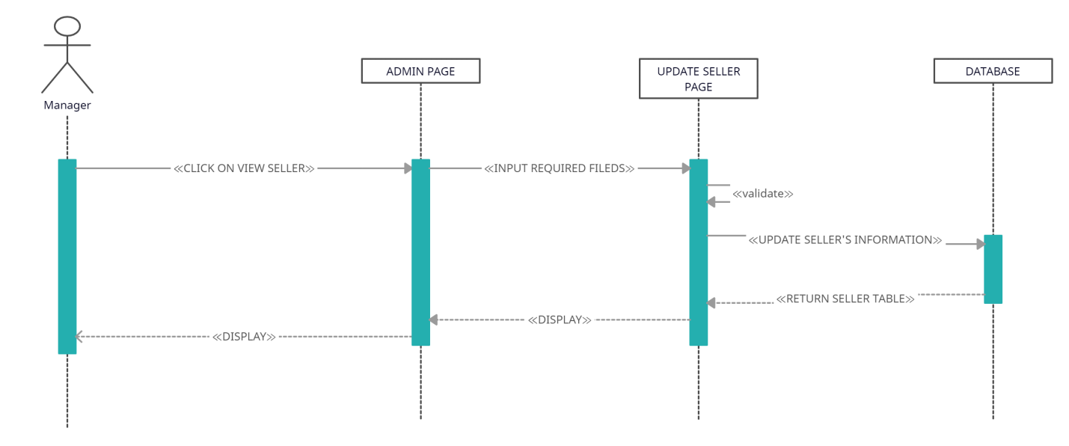

6/ Manage Seller – create:

|  |  |  |
| --- | --- | --- |
| **Use Case Name** | Manage Seller - create | |
| **Actors** | Manager | |
| **Description** | Manager wants to create new seller account | |
| **Requirements** | Login as Manager | |
|  | **Actor Actions** | **System Responses** |
| **Basic Flow** | - Fill in compulsory information for seller.  - Click create button. | - Insert information of new seller account in database.  - Display new seller’s account on Admin page. |

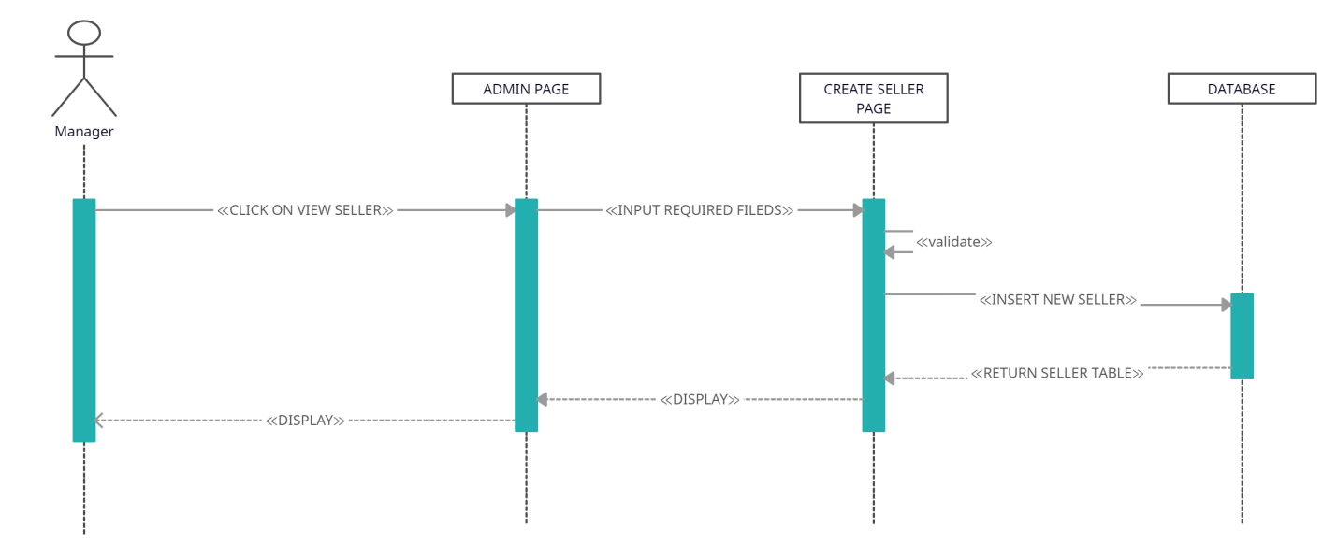

7/ Manage Seller – delete:

|  |  |  |
| --- | --- | --- |
| **Use Case Name** | Manage Seller - delete | |
| **Actors** | Manager | |
| **Description** | Manager wants to delete existing seller account | |
| **Requirements** | Login as Manager | |
|  | **Actor Actions** | **System Responses** |
| **Basic Flow** | - Search for seller account which they want to delete.  - Click delete button. | - Delete seller account matched with the input data. |

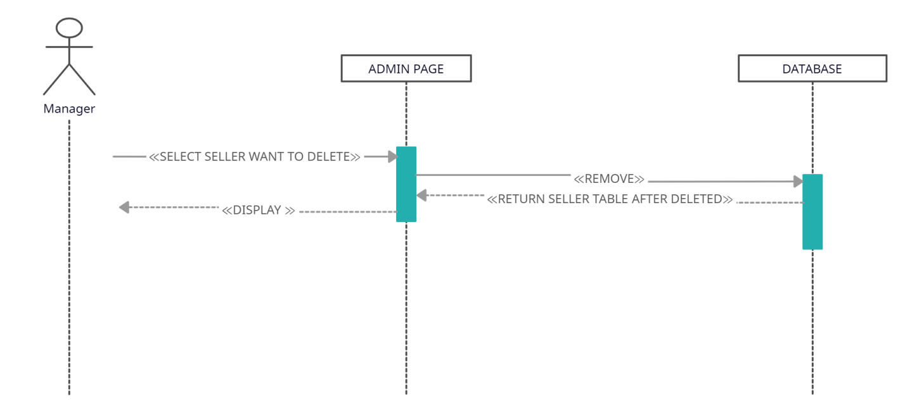

**b) ADMIN:**

1/ Manage Manager – read:

|  |  |  |
| --- | --- | --- |
| **Use Case Name** | Manage Manager - read | |
| **Actors** | Admin | |
| **Description** | Admin wants to view manager information | |
| **Requirements** | Login as Admin | |
|  | **Actor Actions** | **System Responses** |
| **Basic Flow** | Click on view seller navigator | Display manager’s information table |

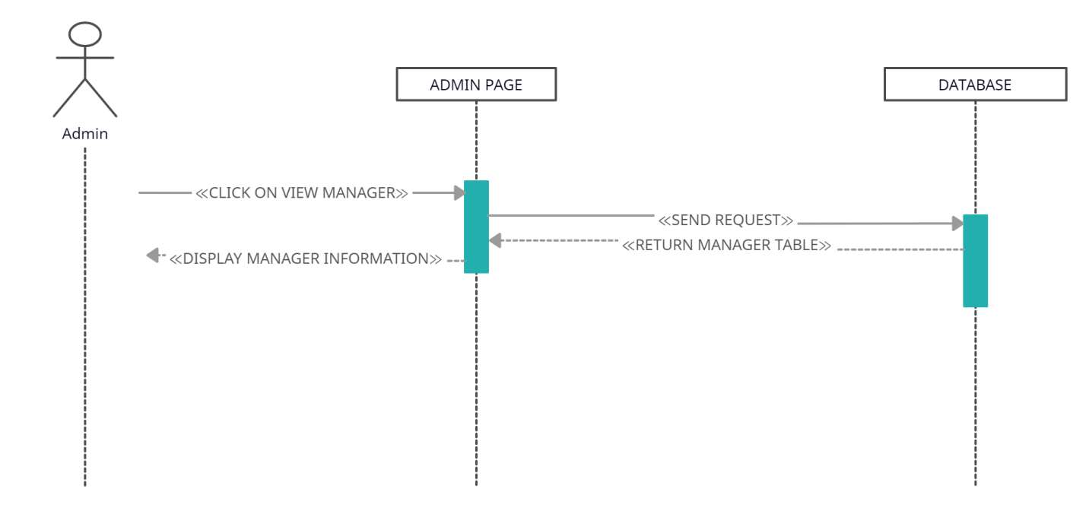

2/ Manage Manager – update:

|  |  |  |
| --- | --- | --- |
| **Use Case Name** | Manage Manager - update | |
| **Actors** | Admin | |
| **Description** | Admin wants to update manager’s information | |
| **Requirements** | Login as Admin | |
|  | **Actor Actions** | **System Responses** |
| **Basic Flow** | - Edit manager’s information that they want to adjust.  - Click update button. | - Update new information for manager in database.  - Display new manager’s information on Admin page. |

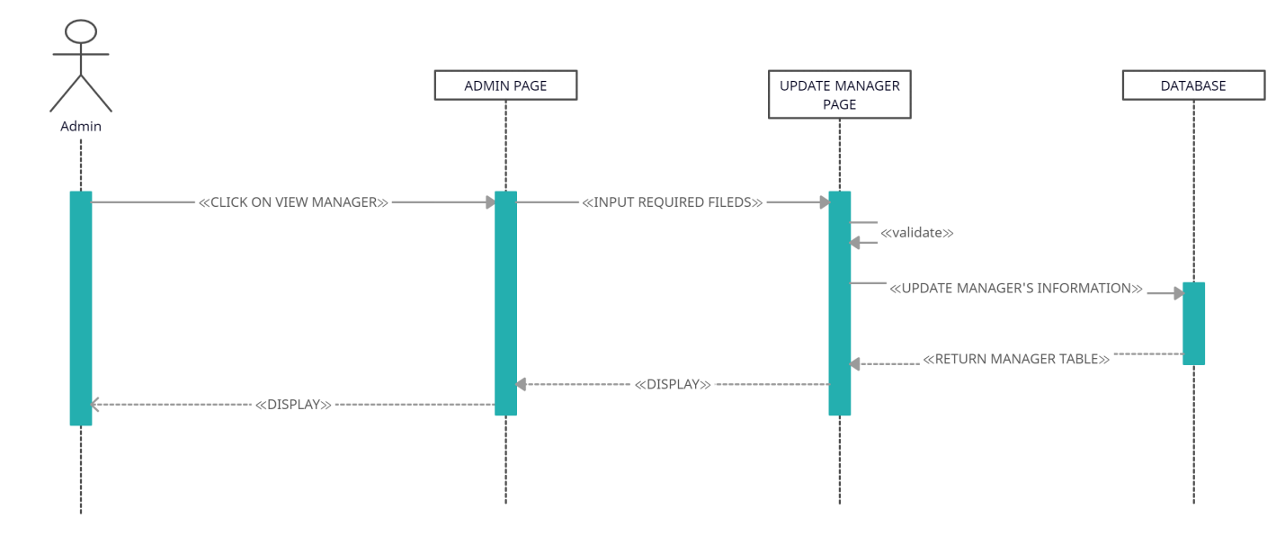

3/ Manage Manager – create:

|  |  |  |
| --- | --- | --- |
| **Use Case Name** | Manage Manager- create | |
| **Actors** | Admin | |
| **Description** | Admin wants to create new manager account | |
| **Requirements** | Login as Admin | |
|  | **Actor Actions** | **System Responses** |
| **Basic Flow** | - Fill in compulsory information for manager.  - Click create button. | - Insert information of new manager account in database.  - Display new manager’s account on Admin page. |

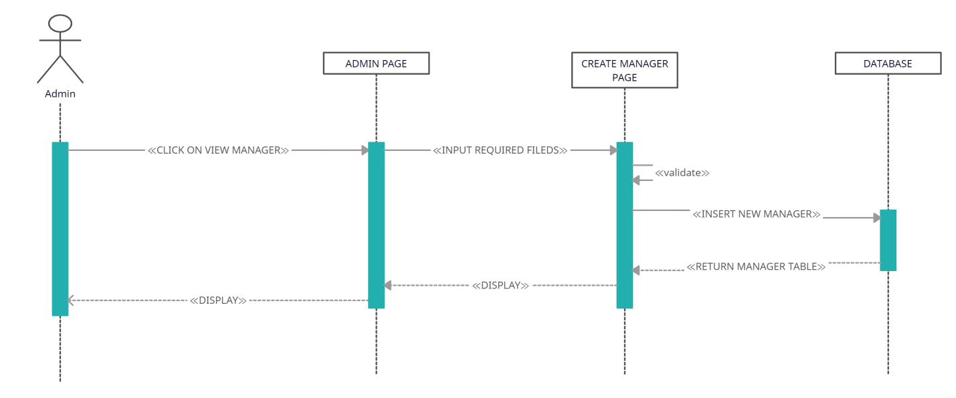

4/ Manage Manager – delete:

|  |  |  |
| --- | --- | --- |
| **Use Case Name** | Manage Manager - delete | |
| **Actors** | Admin | |
| **Description** | Admin wants to delete existing manager account | |
| **Requirements** | Login as Admin | |
|  | **Actor Actions** | **System Responses** |
| **Basic Flow** | - Search for manager account which they want to delete.  - Click delete button. | - Delete manager account matched with the input data. |

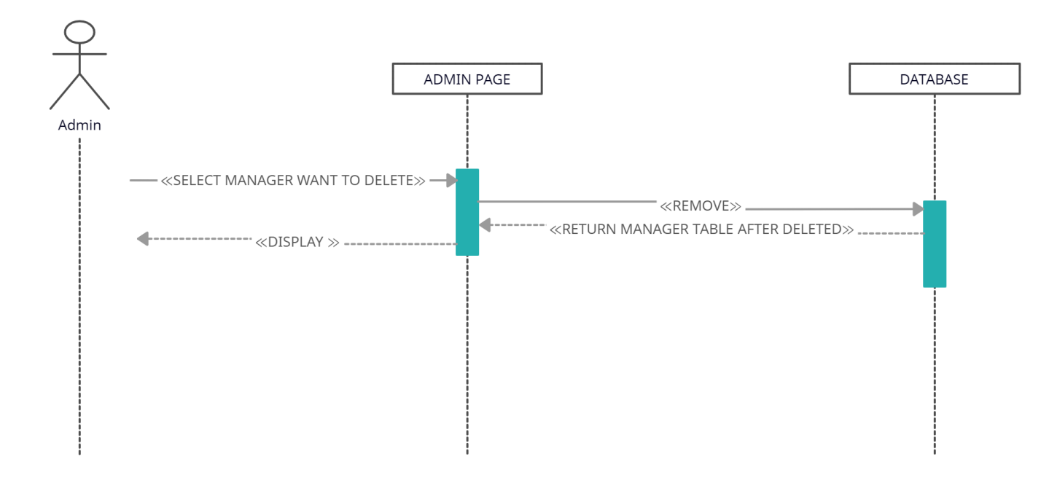

5/ Manage Product – read:

|  |  |  |
| --- | --- | --- |
| **Use Case Name** | Manage Product - read | |
| **Actors** | Admin | |
| **Description** | Admin wants to view product information | |
| **Requirements** | Login as Admin | |
|  | **Actor Actions** | **System Responses** |
| **Basic Flow** | - Click on view product navigator | - Display product’s information table |

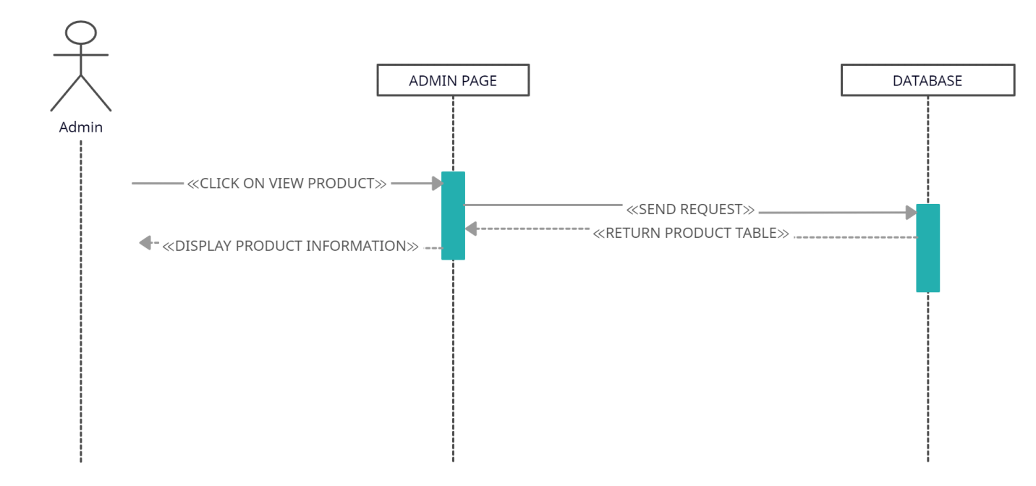

6/ Manage Product – create:

|  |  |  |
| --- | --- | --- |
| **Use Case Name** | Manage Product - create | |
| **Actors** | Admin | |
| **Description** | Admin wants to create new product | |
| **Requirements** | Login as Admin | |
|  | **Actor Actions** | **System Responses** |
| **Basic Flow** | - Input required fields: productID, productName, Price, Image, Description, Category…  - Click create button | - System checks the input information.  - Insert new product in database.  - Display new product on Admin page. |

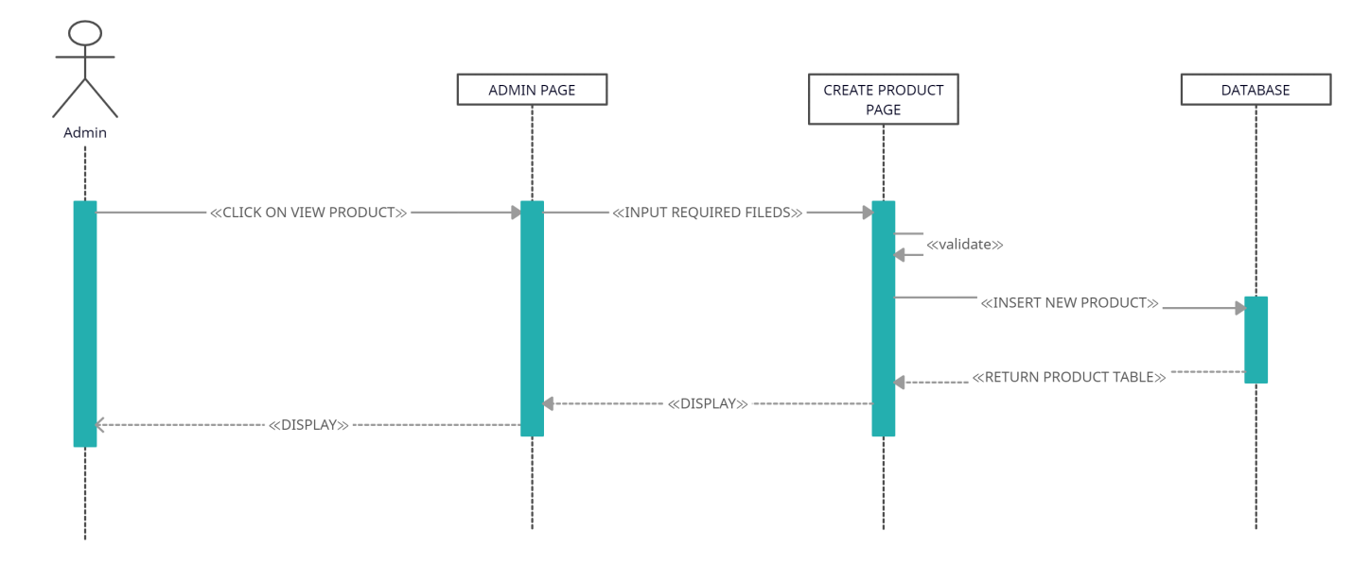

7/ Manage Product – update:

|  |  |  |
| --- | --- | --- |
| **Use Case Name** | Manage Product - update | |
| **Actors** | Admin | |
| **Description** | Admin wants to update product’s information | |
| **Requirements** | Login as Admin | |
|  | **Actor Actions** | **System Responses** |
| **Basic Flow** | - Input required fields: productID, productName, Price, Image, Description, Category…  - Click update button | - System checks the input information.  - Update new product’s information in database.  - Display updated product’s information on Admin page. |

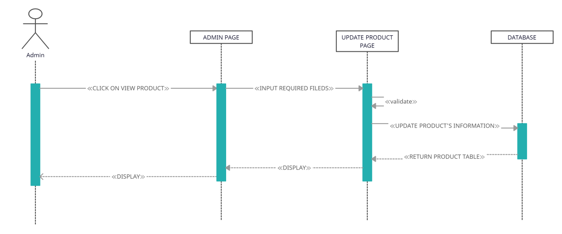

8/ Manage Product – inactive:

|  |  |  |
| --- | --- | --- |
| **Use Case Name** | Manage Product - delete | |
| **Actors** | Admin | |
| **Description** | Admin wants to delete existing product | |
| **Requirements** | Login as Admin | |
|  | **Actor Actions** | **System Responses** |
| **Basic Flow** | - Click to the existing product which they want to inactive.  - Click inactive button. | - Inactive the existing product matched with the input data. |

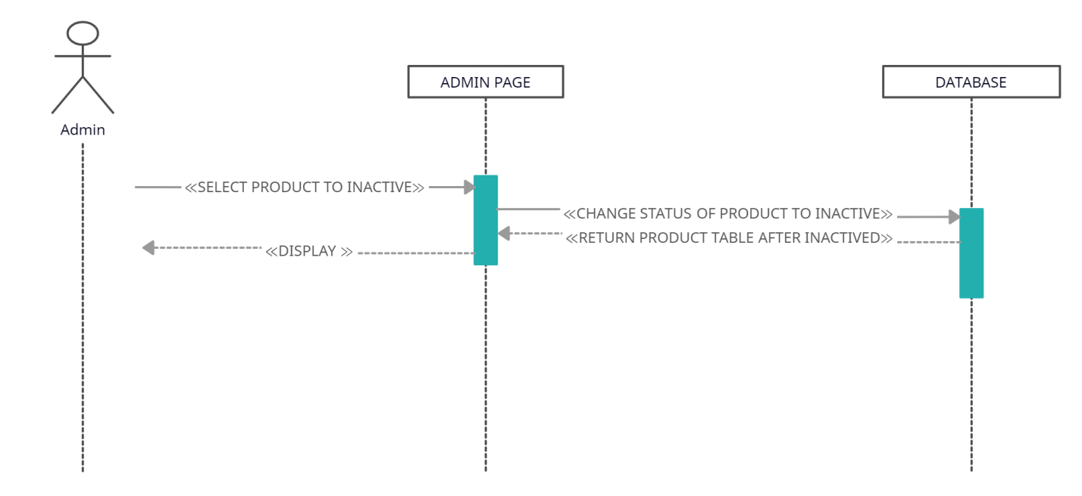

9/ Manage Promotion – read:

|  |  |  |
| --- | --- | --- |
| **Use Case Name** | Manage Promotion - read | |
| **Actors** | Admin | |
| **Description** | Admin wants to view promotion | |
| **Requirements** | Login as Admin | |
|  | **Actor Actions** | **System Responses** |
| **Basic Flow** | - Click on view promotion navigator | - Display promotion’s information table |

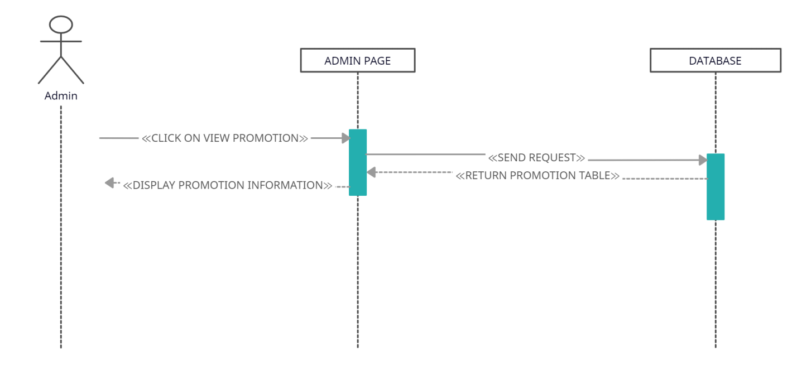

10/ Manage Promotion – create:

|  |  |  |
| --- | --- | --- |
| **Use Case Name** | Manage Promotion - create | |
| **Actors** | Admin | |
| **Description** | Admin wants to create new promotion | |
| **Requirements** | Login as Admin | |
|  | **Actor Actions** | **System Responses** |
| **Basic Flow** | - Input required fields: promotionID, promotionName, Image, Description…  - Click create button | - System checks the input information.  - Insert new promotion in database.  - Display new promotion on Admin page. |

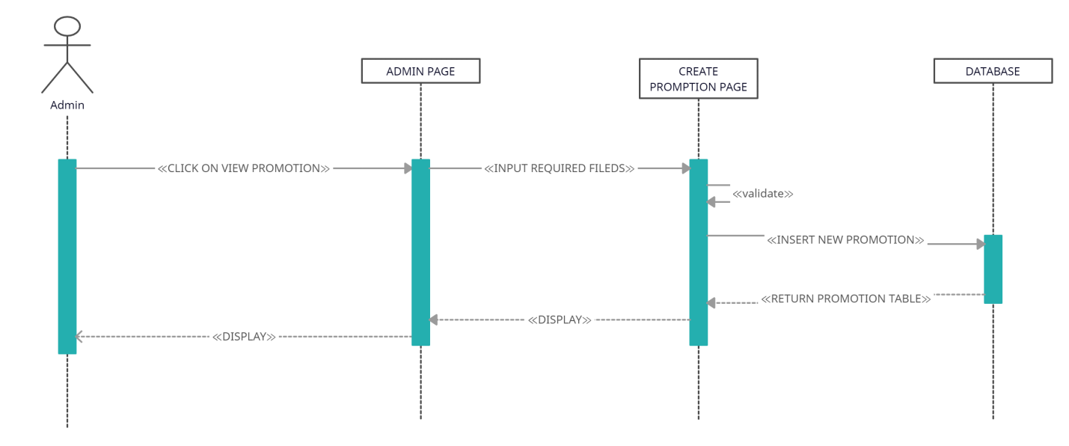

11/ Manage Promotion – update:

|  |  |  |
| --- | --- | --- |
| **Use Case Name** | Manage Promotion - update | |
| **Actors** | Admin | |
| **Description** | Admin wants to update promotion’s information | |
| **Requirements** | Login as Admin | |
|  | **Actor Actions** | **System Responses** |
| **Basic Flow** | - Input required fields: promotionID, promotionName, Image, Description…  - Click update button | - System checks the input information.  - Update promotion’s information in database.  - Display updated promotion’s information on Admin page. |

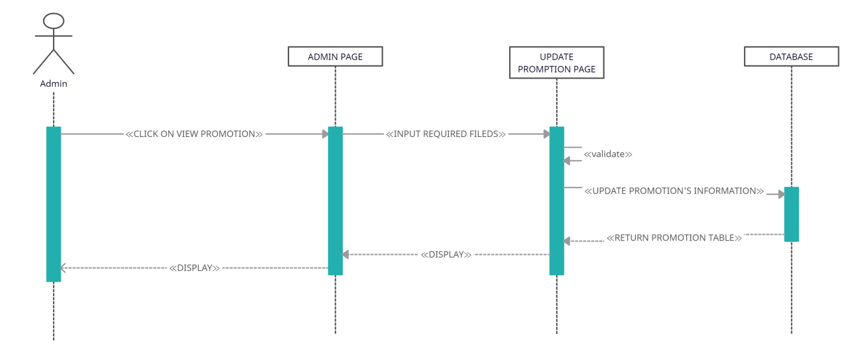

12/ Manage Promotion – delete:

|  |  |  |
| --- | --- | --- |
| **Use Case Name** | Manage Promotion - delete | |
| **Actors** | Admin | |
| **Description** | Admin wants to delete existing promotion | |
| **Requirements** | Login as Admin | |
|  | **Actor Actions** | **System Responses** |
| **Basic Flow** | - Click to the existing promotion which they want to delete.  - Click delete button. | - Delete the existing promotion matched with the input data. |

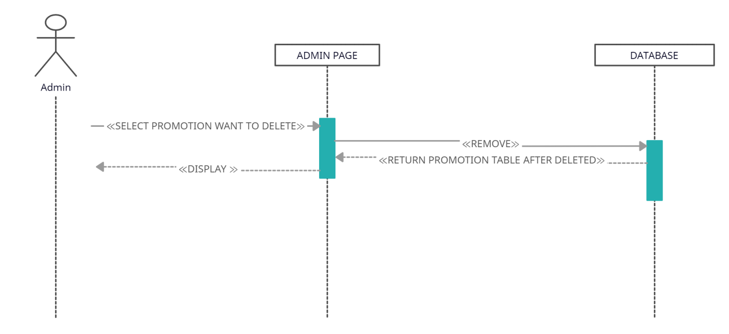

13/ Manage Feedback – read:

|  |  |  |
| --- | --- | --- |
| **Use Case Name** | Manage Feedback - read | |
| **Actors** | Admin | |
| **Description** | Admin wants to view feedback | |
| **Requirements** | Login as Admin | |
|  | **Actor Actions** | **System Responses** |
| **Basic Flow** | - Click on view feedback navigator | - Display feedback’s information table |

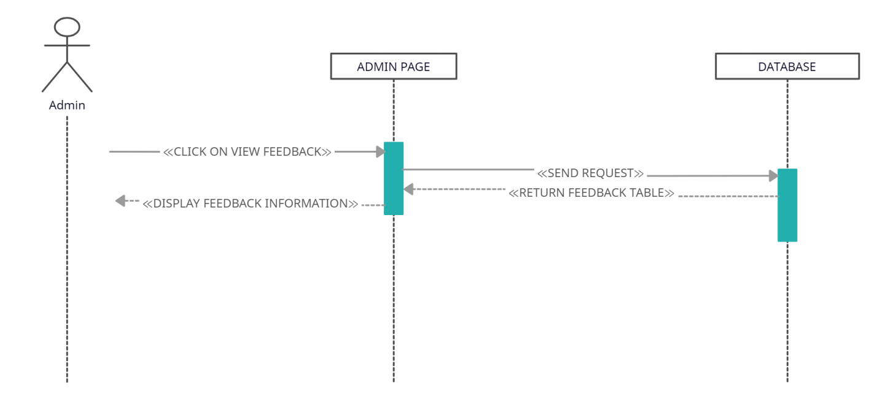

14/ Manage Feedback – delete:

|  |  |  |
| --- | --- | --- |
| **Use Case Name** | Manage Feedback - delete | |
| **Actors** | Admin | |
| **Description** | Admin wants to delete existing feedback | |
| **Requirements** | Login as Admin | |
|  | **Actor Actions** | **System Responses** |
| **Basic Flow** | - Click to the existing feedback which they want to delete.  - Click delete button. | - Delete the existing feedback matched with the input data. |

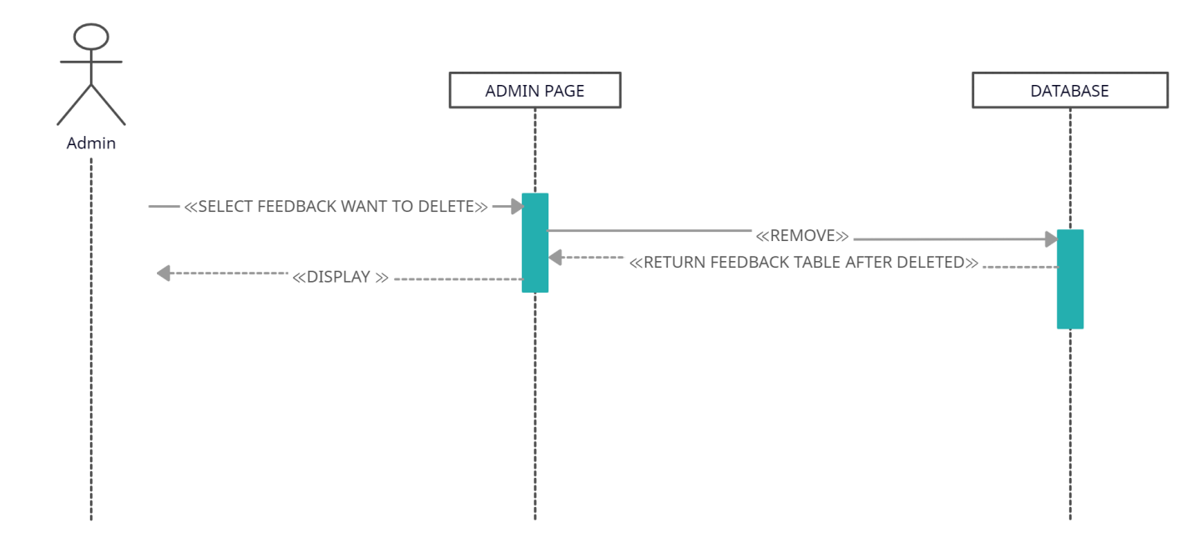

15/ Manage Category – read:

|  |  |  |
| --- | --- | --- |
| **Use Case Name** | Manage Product - read | |
| **Actors** | Admin | |
| **Description** | Admin wants to view product information | |
| **Requirements** | Login as Admin | |
|  | **Actor Actions** | **System Responses** |
| **Basic Flow** | - Click on view product navigator | - Display product’s information table |



16/ Manage Category – create:

|  |  |  |
| --- | --- | --- |
| **Use Case Name** | Manage Product - create | |
| **Actors** | Admin | |
| **Description** | Admin wants to create new product | |
| **Requirements** | Login as Admin | |
|  | **Actor Actions** | **System Responses** |
| **Basic Flow** | - Input required fields: productID, productName, Price, Image, Description, Category…  - Click create button | - System checks the input information.  - Insert new product in database.  - Display new product on Admin page. |



17/ Manage Category – update:

|  |  |  |
| --- | --- | --- |
| **Use Case Name** | Manage Product - update | |
| **Actors** | Admin | |
| **Description** | Admin wants to update product’s information | |
| **Requirements** | Login as Admin | |
|  | **Actor Actions** | **System Responses** |
| **Basic Flow** | - Input required fields: productID, productName, Price, Image, Description, Category…  - Click update button | - System checks the input information.  - Update new product’s information in database.  - Display updated product’s information on Admin page. |



18/ Manage Category – inactive:

|  |  |  |
| --- | --- | --- |
| **Use Case Name** | Manage Product - delete | |
| **Actors** | Admin | |
| **Description** | Admin wants to delete existing product | |
| **Requirements** | Login as Admin | |
|  | **Actor Actions** | **System Responses** |
| **Basic Flow** | - Click to the existing product which they want to inactive.  - Click inactive button. | - Inactive the existing product matched with the input data. |



## 2. Guest Page:

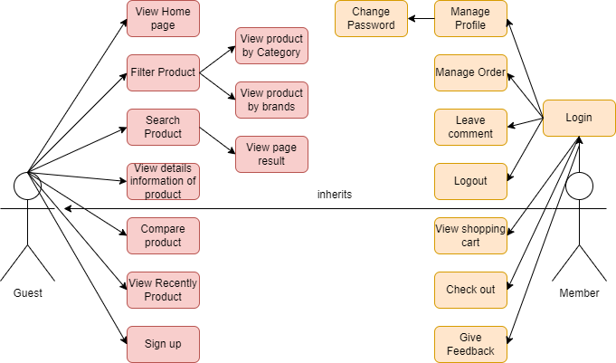

**1.Guest:**

a.Search

a.1. Auto Complete:

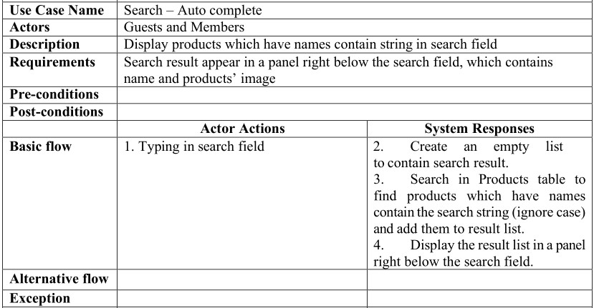

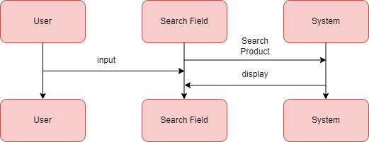

a.2. Search button:

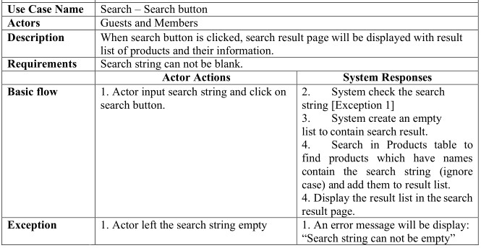

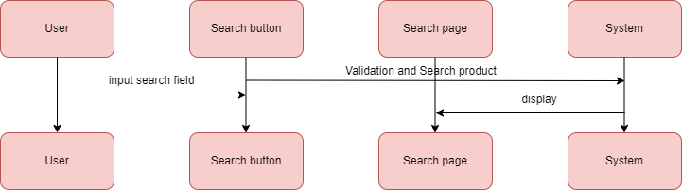

b.Filter:

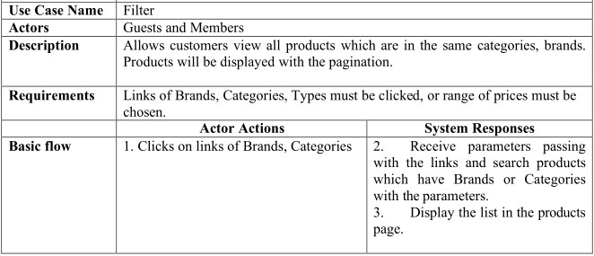

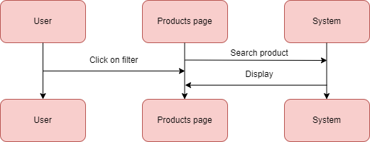

c. View product details:

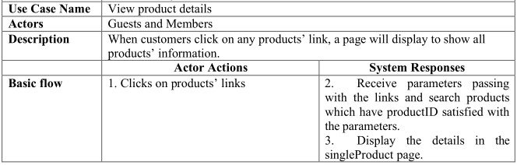

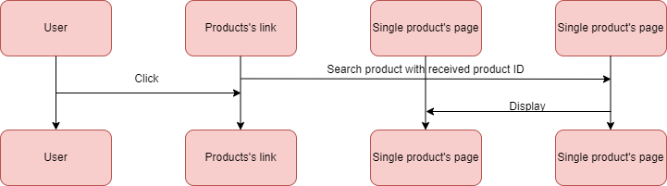

d. Compare

d.1.Add:

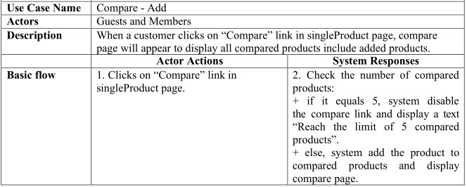

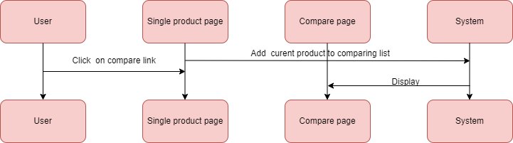

d.2.Remove:

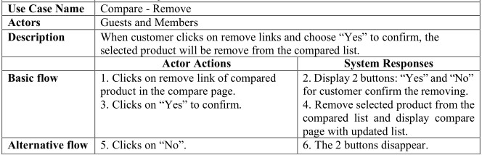

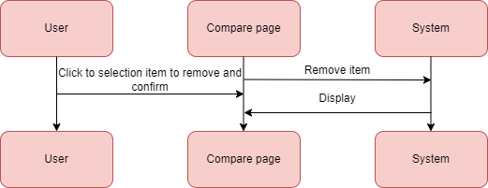

e. Sign up:

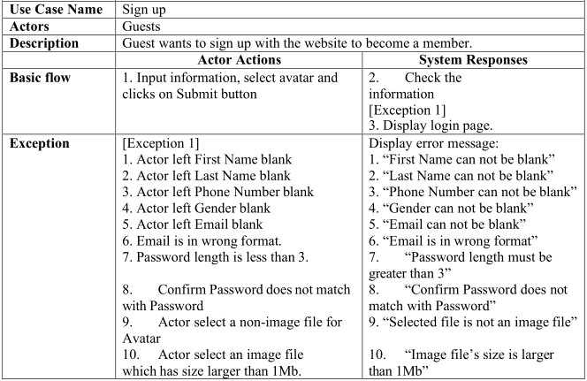

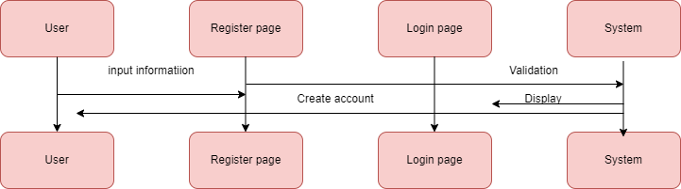

## 2.Member

a.Login

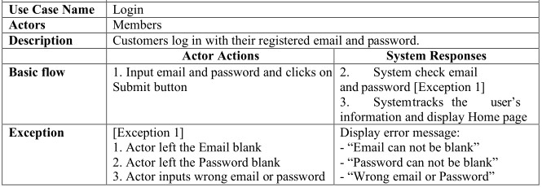

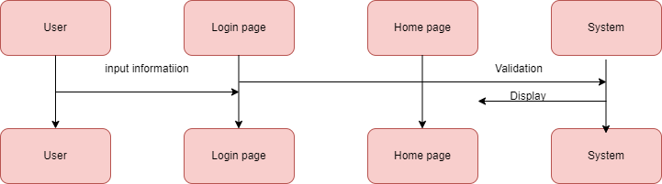

b. Update private information

b1. Update information

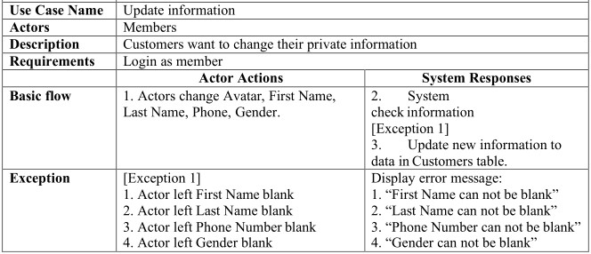

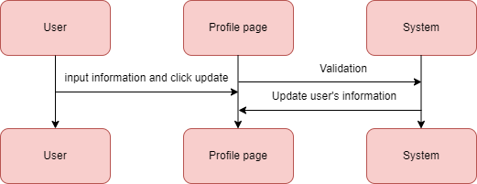

B2. Change password

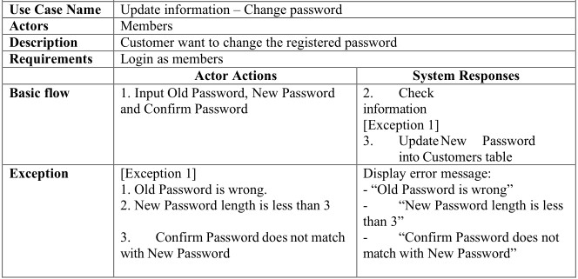

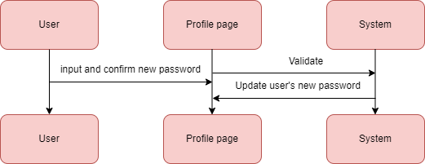

c. Manager orders:

c.1. View all orders:

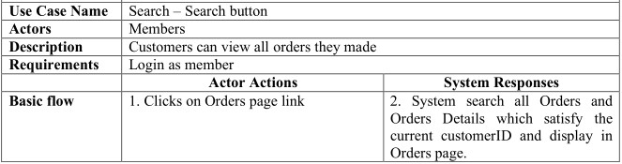

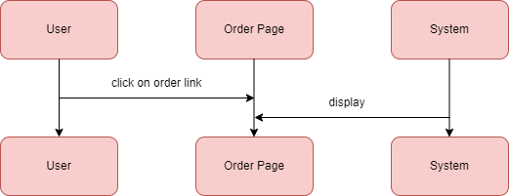

C2. View orders details:

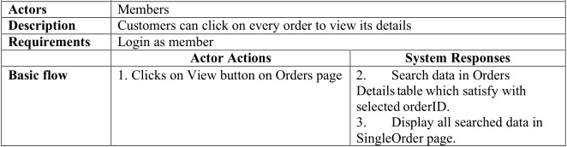

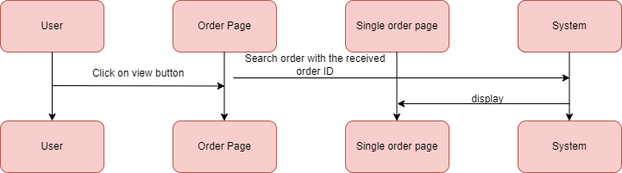

d. Cart

d.1.Add:

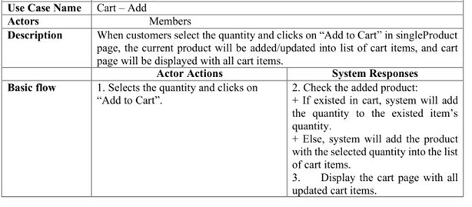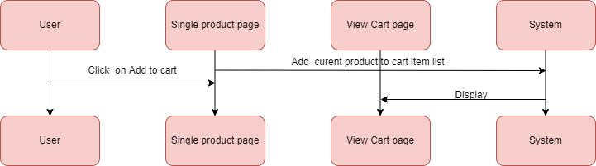

d.2.Remove

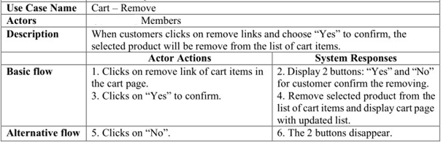

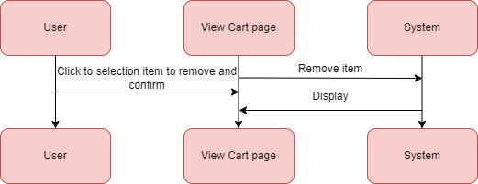

d.3. Update quantity:

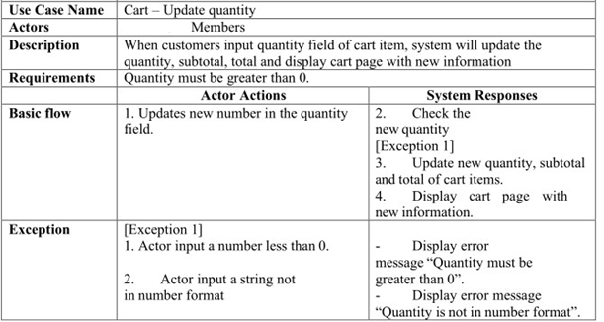

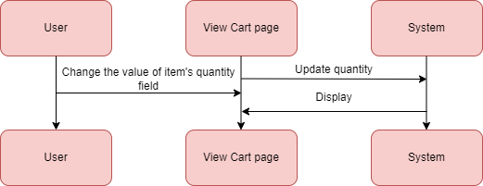

e.Checkout

e.1.Input information

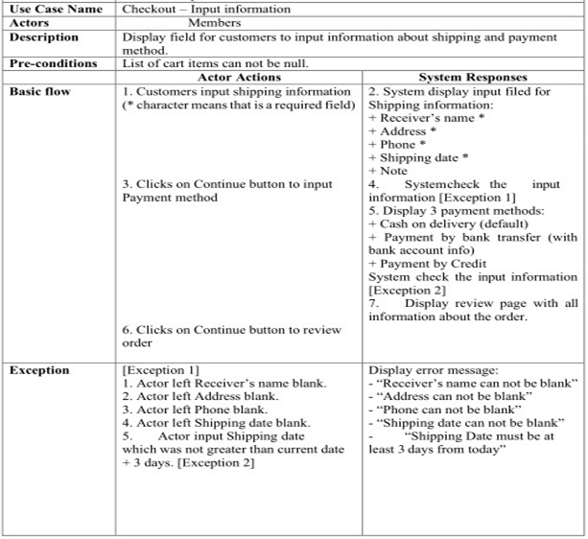

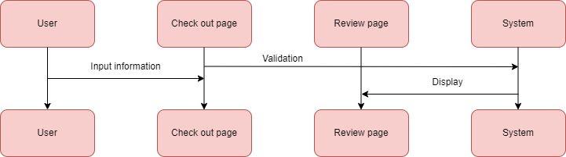

e.2. Confirm order:

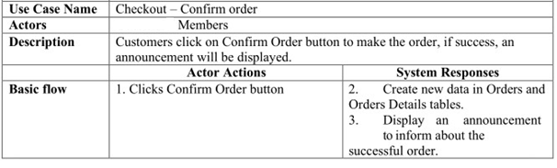

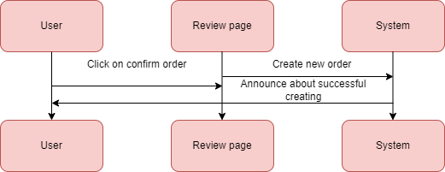

# Entity Relationship Diagram

## Entity Relationship Diagram (ERD):

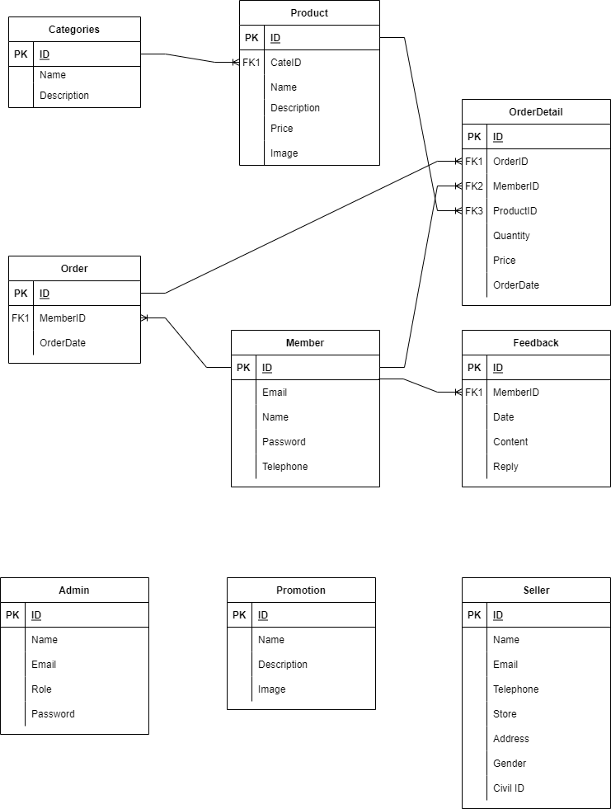

## Table:

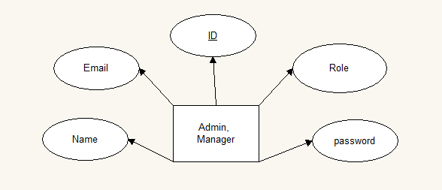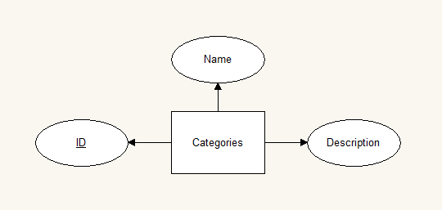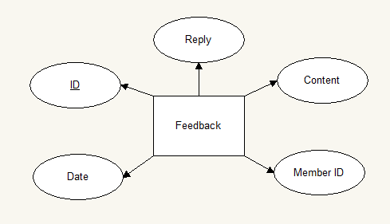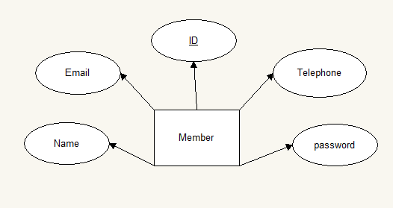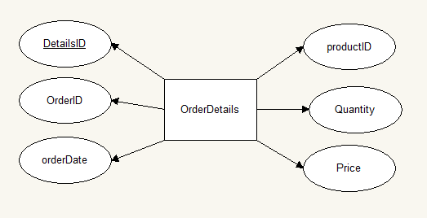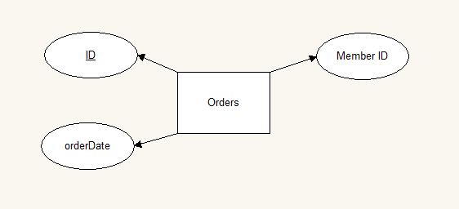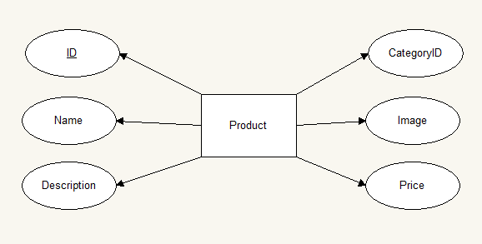

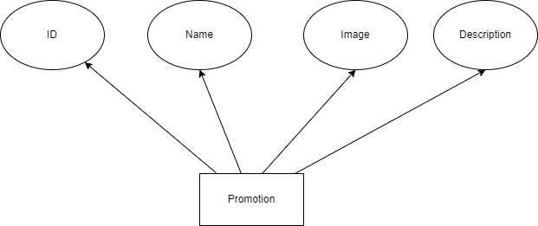

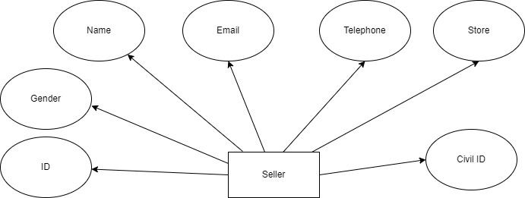

## Table Design:

1.Admin:

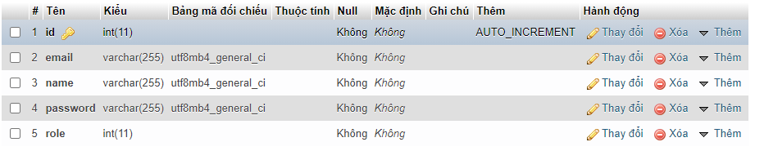

2.Categories: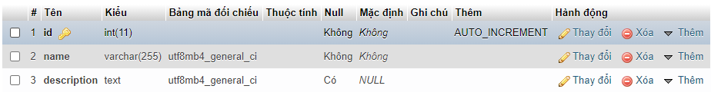

3.Feedback: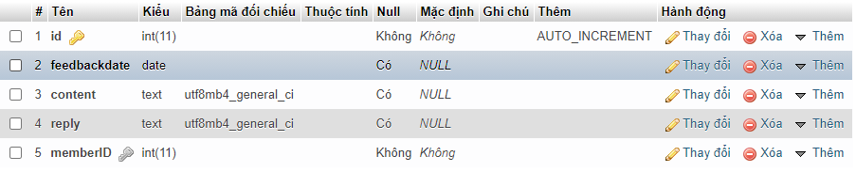

4.Member: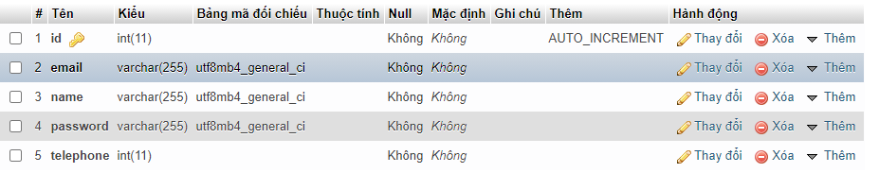

5.OrderDetails: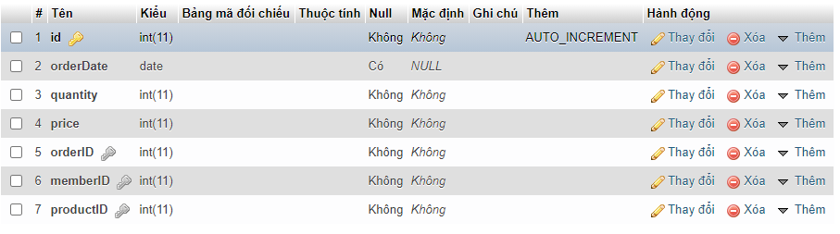

6.Order: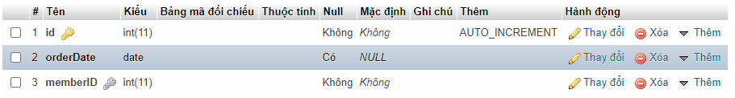

7.Product: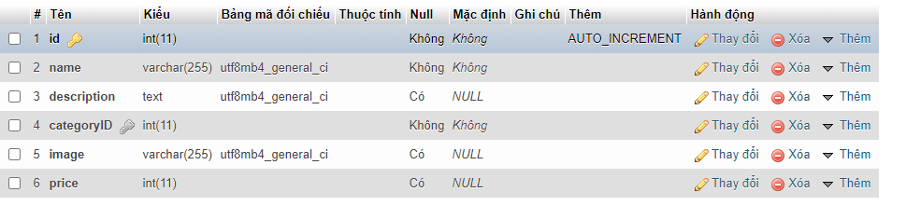

8.Promotion:

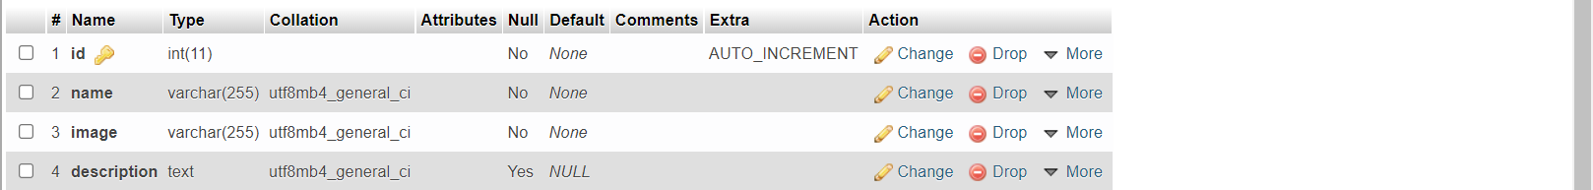

9.Seller:

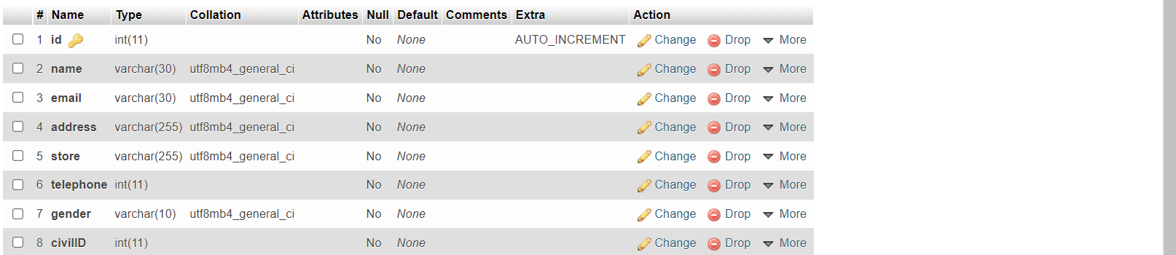

# SITEMAP

## 1/GUEST SITE:

Edit Personal Info

Home

Product

About Us

Contact

Login/Register

Shopping Cart

Feedback

Search

Product detail

View Current/History Order

Add/Remove Cart

Filter

Compare

## 2/ADMIN SITE:

Member

Login

Main

Member

Admin

Product

Promotion

Order

Feedback

Create/View/Update

Create/View/Update/Delete

Create/View/Update/Inactive

Create/View/Update/Delete

View/Delete

Seller

Brand

Category

Admin

Manager

View/Update/Delete

Create/View/Update/Inactive

Create/View/Update/Inactive

View/Delete/Reply

Order

View/Update

View

# TASK SHEET REVIEW 2

|  |  |  |  |  |
| --- | --- | --- | --- | --- |
| **No.** | **Description** | **Begin Date** | **TeamMate Name** | **Notes** |
| 1 | Entities and ER Diagram Admin Page | 14/12/2021 | Le Huu Thang |  |
| 2 | Entities and ER Diagram Guest Page | Do Dinh Dai |  |
| 3 | Sitemap for visior’s website and description | Le Huu Thang |  |
| 4 | Sitemap for admin’s website and description | Le Huu Thang |  |
| 5 | ERD and Table design |  | Nguyen Hoang Minh |  |

|  |  |
| --- | --- |
| **Date:** | |
| Signature of Instructor:  **MRS.DAO NGOC ANH** | Signature of Team Leader:  **MR.LE HUU THANG** |

# USER INTERFACE

## 1. Home page:

1. **Overview:**

The home page gives an overview of the company information, and product menu. The webpage including: a slideshow of introduction, list of products menu, promotions...

1. **Frame:**

**HEADER**

**(LOGO – ACOUNT-CREAT AN ACCOUNT)**

**PICTURE SLIDESHOW**

**(PROMOTION)**

**SLIDESHOW LIST OF PRODUCTS**

**PRODUTS**

**FOOTER**

**NAVIGATION BAR**

|  |
| --- |
| 2. Product page:  1. **Overview:**   The product page gives an overview list of products.   1. **Frame:**   **HEADER**  **(LOGO – ACOUNT-CREAT AN ACCOUNT)**  **NAVIGATION BAR**  **product**  **product**  **product**  **product**  **FOOTER** 3. Contact page:  1. **Overview:**   The product page gives an overview list of products.   1. **Frame:**   **HEADER**  **(LOGO – ACOUNT-CREAT AN ACCOUNT)**  **NAVIGATION BAR**  **Store Location**  **Store Location**  **Store Location**  **FOOTER** 4. Product Detail Page:  1. **Overview:**   The product detail page gives information detail of the specific product and allows member to order the product they want.   1. **Frame:** |
| **NAVIGATION BAR**  **HEADER**  **(LOGO – ACOUNT-CREAT AN ACCOUNT)**  **FOOTER**  **PRODUCT INFORMATION DETAIL** 5. Login Page:  1. **Overview:**   The login page allows member can login into their account.   1. **Frame:**   **LOGIN**  **REGISTER**  **EMAIL**  **PASSWORD**  **LOGIN** |

## 6. Register Page:

1. **Overview:**

The login page allows member can register their account.

1. **Frame:**

**LOGIN**

**REGISTER**

**EMAIL**

**PASSWORD**

**REGISTER**

**CONFIRM PASSWORD**

## 7. Cart:

1. **Overview:**

The Cart page allows member can view their orders.

1. **Frame:**

**QUANTITY**

**TOTAL**

**PRICE**

**PRODUCT NAME**

**QUANTITY**

**TOTAL**

**TOTAL**

**PRICE**

**PRODUCT NAME**

## 8. About Us:

1. **Overview:**

The About Us page gives our information to customer.

1. **Frame:**

**HEADER**

**(LOGO – ACOUNT-CREAT AN ACCOUNT)**

**NAVIGATION BAR**

**OUR MEMBER INFORMATION**

**FOOTER**

# ADMIN INTERFACE

## 1. Login page:

1. **Overview:**

The login page grants users access to the management system according to their account types. First of all, this page requires users to provide valid account username, password and account type. After that, it validates user input using data from admin in database. If the input is correct, it will switch to the admin home page of the system.

1. **Frame:**

**LOGIN**

**USERNAME**

**PASSWORD**

**LOGIN**

## 2. View page:

1. **Overview:**

The view page allows admin to view and control the database table like: product, category, admin, promotion… In addition, admin can choose action to conduct like: view, update, or delete/inactive.

1. **Frame:**

**HEADER**

**SIDEBAR**

**LIST OF MENU**

**TABLE NAME**

**INFORMATION**

**INFORMATION**

**INFORMATION**

**ACTION**

**ACTION**

**ACTION**

**FOOTER**

## 3. Create page:

1. **Overview:**

The create page allows admin to create new product/admin/category/promotion.

1. **Frame:**

**HEADER**

**SIDEBAR**

**LIST OF MENU**

**CONTENT**

**CONTENT**

**CONTENT**

**TITLE**

**TITLE**

**TITLE**

**CREATE NEW**

**FOOTER**

## 4. Update page:

1. **Overview:**

The update page allows admin to change or adjust information of product/admin/category/promotion table.

1. **Frame:**

**FOOTER**

**CONTENT**

**TITLE**

**CONTENT**

**TITLE**

**CONTENT**

**TITLE**

**UPDATE**

**SIDEBAR**

**LIST OF MENU**

**HEADER**

# TASK SHEET REVIEW 3

|  |  |  |  |  |
| --- | --- | --- | --- | --- |
| **No.** | **Description** | **Begin Date** | **TeamMate Name** | **Notes** |
| 1 | User – Home, History Cart, User Information | 21/12/2021 | Le Huu Thang |  |
| 2 | User – Product, Product Detail, Order | Do Dinh Dai |  |
| 3 | User – About us, Contact us, Login/Register, Feedback | Nguyen Hoang Minh |  |
| 4 | Admin – Admin, Seller, Promotion, Member, Order |  | Le Huu Thang |  |
| 5 | Admin – Login/Register |  | Le Huu Thang |  |
| 6 | Admin – Product, Brand, Category |  | Do Dinh Dai |  |

|  |  |
| --- | --- |
| **Date:** | |
| Signature of Instructor:  **MRS.DAO NGOC ANH** | Signature of Team Leader:  **MR.LE HUU THANG** |